1. **Agenda:**
   1. Running Products MS to check how createProduct() works.
2. This time product create event will be published synchronously rather than asynchronously.
3. 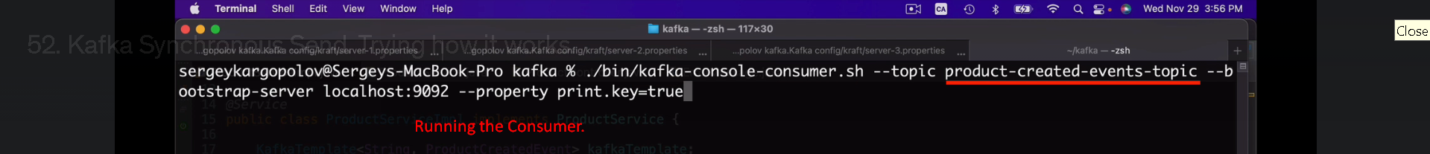
4. 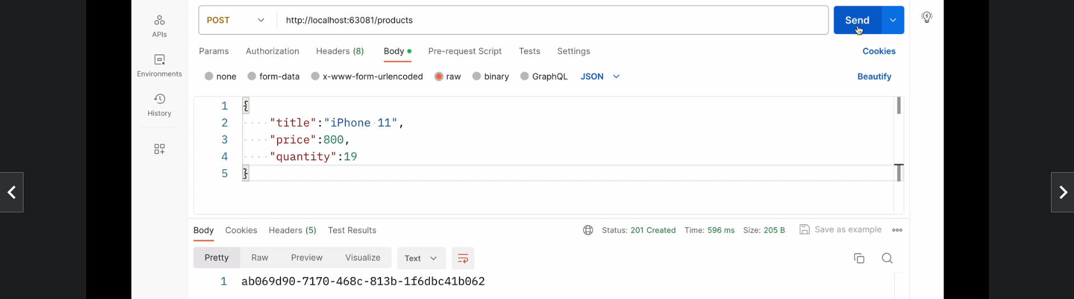
5. 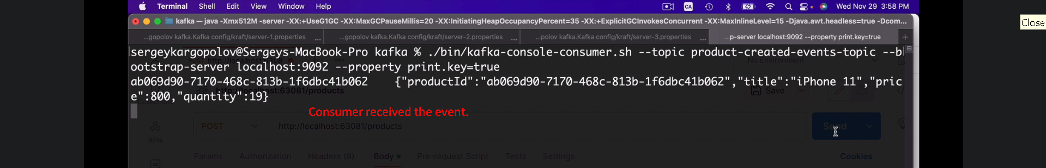
6. 